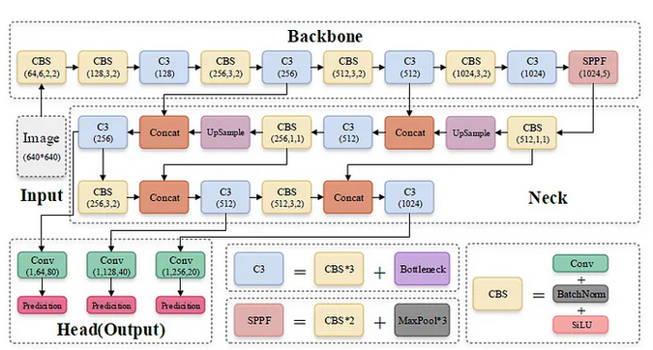








YOLOv5 in FPGA
YOLOv5 in FPGA
This repo is about how can we deploy the yolov5 object detection model on Kria KV260 FPGA board.
To deploy yolov5 in FPGA board, we need to modify the layers of the model because all of the layers of yolov5 are not supportable in DPU of FPGA board. So, we need to find out those unsupported layers/operators either by mannually reading from or by doing inspection.
About YOLOv5:
Yolov5 build upon the foundation laid by YOLO that has granered significant attention due to its exceptional performance and efficiency.
This model addresses the trade-off between accuracy and inference speed across various yolov5 variants (n,s,m,l,x).
Architecture:
The architecture of yolov5 consists of three stages i.e. Backbone, Neck and Head.
1. Backbone:
It is basically a stack of convolutional layers that extracts the features from input image at different scales.
Here, backbone is modified CSPDarknet53.

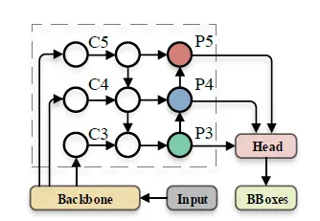


It stacks multiple CBS (Convolution + BatcNormalization + SiLU) modules and C3 modules and at last it has SPPF module which is used to increase the receptive field of the model.
Here, CBS is used to assist the C3 module in feature extraction process.
2. Neck:
This stage combines the features of different scales came from backbone and produces the fine-grained fetures so that the objects of different scales can be detected.
Yolov5 uses PAN (Path Aggregation Network) in neck which first upsamples the high level feature maps and comibines with low level feature maps and downsamples the low level feature maps which is then combines with high level featur maps to produce fine-grained features as shown in figure below:
3. Head:
This stage generates the final outputs i.e. bounding box offsets and
logits for class probabilities.
In head of yolov5, the ouput are decoded in different format than in previous yolo.
The equations used to decode the ouput of yolov5 are:
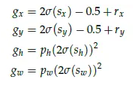
Here, sx, sy are predicted center point of bounding boxes which are relative to top left corner of cell of grid, sh, sw are predicted offset bounding box height and width, rx, ry are top left corner point of cell of grid and ph, pw are height and width of anchors.
Model Check:

As we know that the author of yolov5 is Ultralytics who developed yolov5 architecture on the basis of previous YOLO and also it was the first time the yolo version was implemented using PyTorch.
We can use different variants of yolov5 for object detection from official github repo of ultralytics as i have mentioned in referece section [4].
But here, i have used yolov5 object detection model from a github repo as i have mentioned reference section [1]. This repo is also referenced from ultralytics and there is no difference in model so i used this repo.
So first of all, i have checked the architecture and model by using its pretrained weight to make sure that the model is working or not, which was good.
There was no python script for the inference, but there is jupyter notebook. So i created an inference and evaluation scirpt for this.
Deployment:
To deploy any CNN model, we need to first check that our model is supportable in DPU or not otherwise we will get multiple DPU subgraph and we have to run model in DPU and CPU separately.
Inspection:
Use inspector from pytorch_nndct.apis in Vitis-AI.
If some operators can't be assigned to DPU, message like this can be seen:
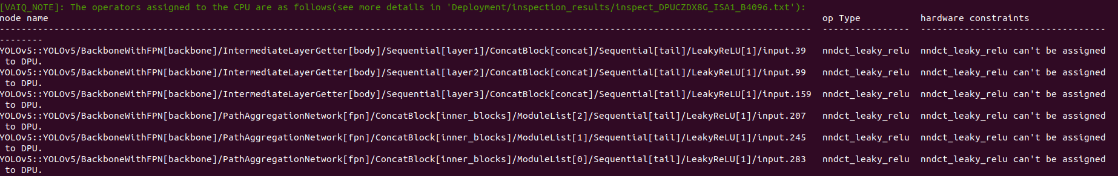
And also inspector gives a svg image where we can see those operators which are assigned to CPU are in RED oval and those which are assigned to DPU are in BLUE oval.

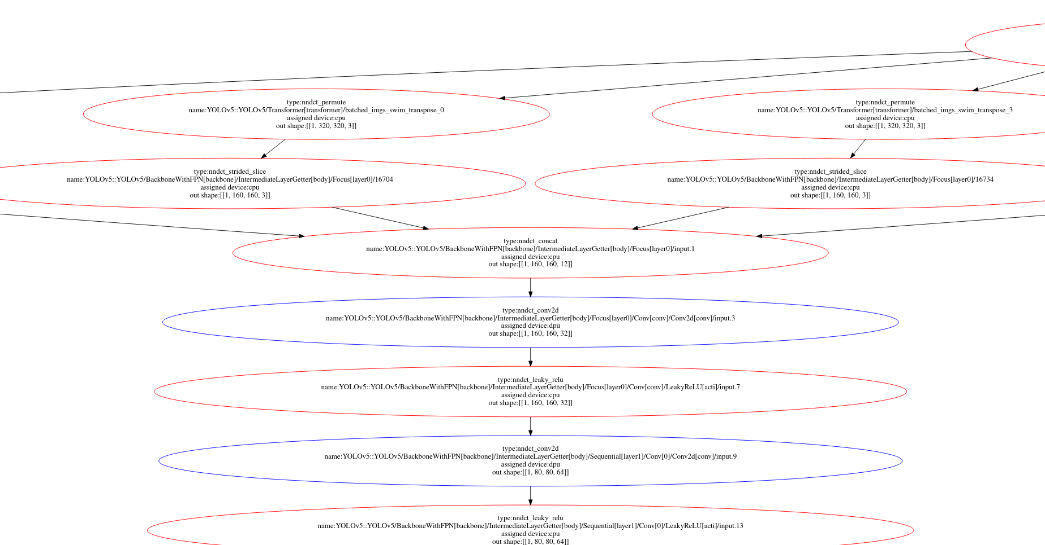
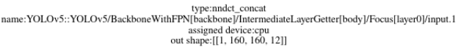
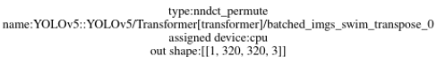
Unsupported operators found in Yolov5:
Sigmoid activation function.
Negative slope of LeakyReLU.
Tensor slicing.
Made unsupported operators supportable in FPGA
Since LeakyReLU with negative slope 0.1 throws this error:
YOLOv5YOLOv5_BackboneWithFPN_backboneIntermediateLayerGetter_bodyFoc us_layer0Conv_convConv2d_convinput_3, type = conv2d-fix has been assigned to CPU: (DPU does not support activation type: LEAKYRELU. Its alpha is 0.100000, but DPU only support 0.1015625.), replaced negative slope of leaky relu activation function by (26/256 = 0.1015625).
Replaced torch.sigmoid() function by torch.Hardsigmoid() because sigmoid is not supported in DPU.
Put Transformer class outside of YOLOv5 class(model) because it performs augmentation and preprocessing steps like flip, mosaic, resize, etc which contains unsupported operators like tensor slicing, permute,etc.
Put the post processing steps happening during the evaluation/inference at the last layer of head that contains unsupported operators like permute, view, etc outside of the model.
Replaced tensor slicing steps in backbone (in Focus class) by a convolutinal layer:

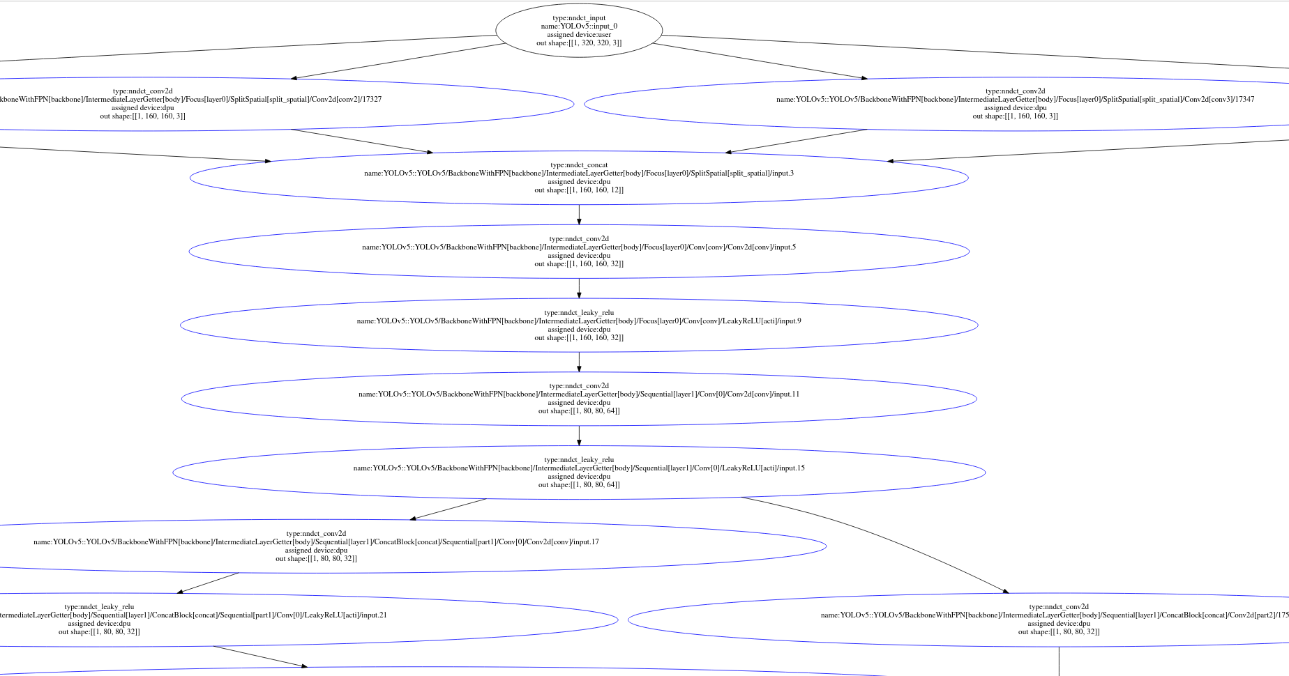
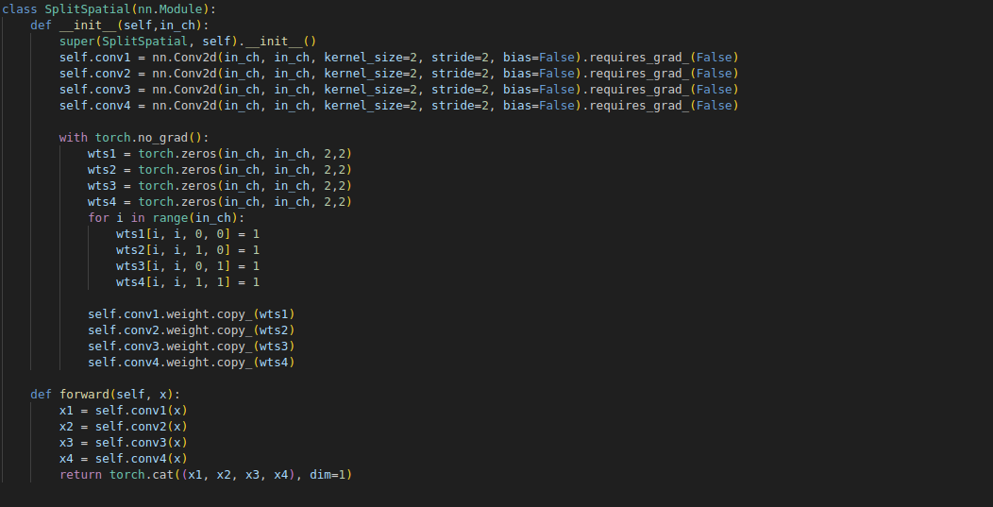
Since, LeakyReLU used with batchnormalization only and from Vitis-AI User Guide 1414 Activations would be fused to adjacent operations such as convolution and add.
So added a convolutional layer with leakyrelu function which has non-trainable parameters and weights are all 1.
After replacing all these operator, the inspector will gives a message like this:
Then the inspector will give an svg image where we can see all the operators are assigned to DPU and are in blue oval.
Result:

From default yolov5 architecture using given pretrained weight, plotted on original image where input images was resized using padding to keep aspect ratio same of original and resized image:
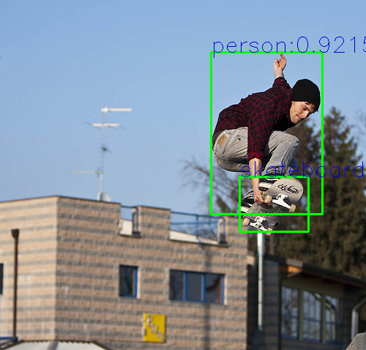
From DPU supportable yolov5 architecture using given pretrained weight, plotted on resized image where input image and plotted image was resized using opencv without considering its aspect ratio:
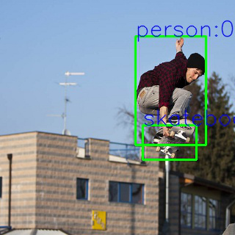
Quantization and Compilation:

Quantized and compiled yolov5 with Vitis-AI quantizer and compiler.
During quantization, if there is no error in quantization code and in model, then we can see the logs like this:
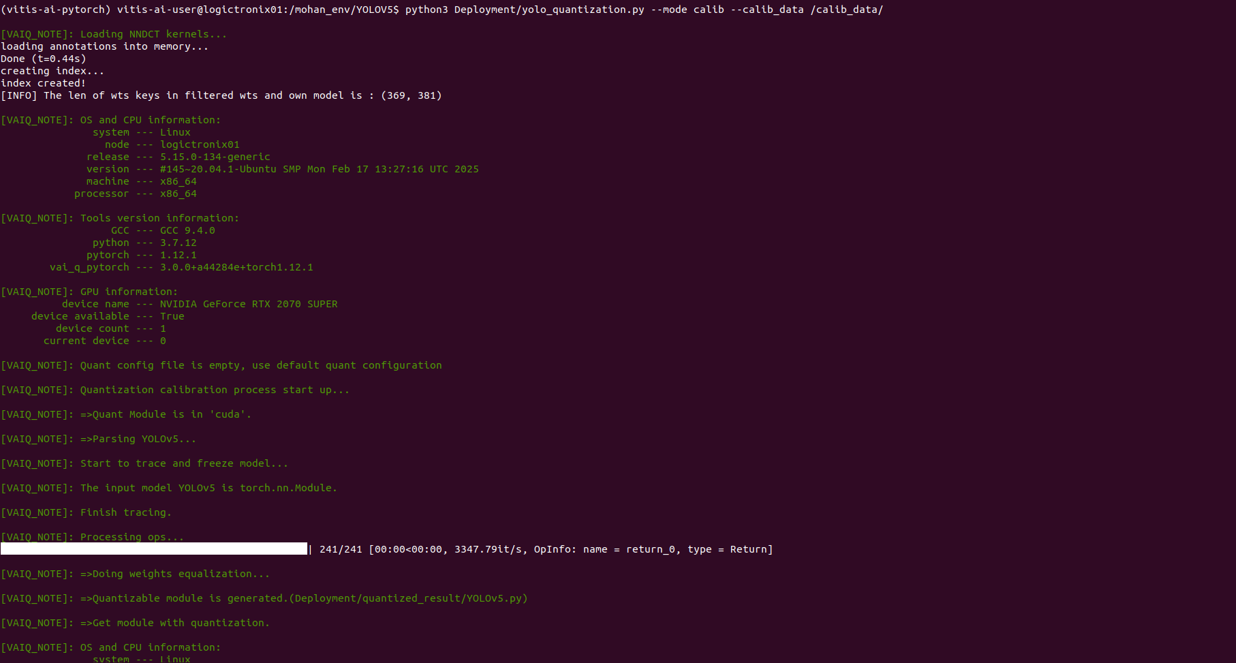
And after successful quantization and compilation, we will get a compiled model (.xmodel) whose number of DPU subgraphs are 1.
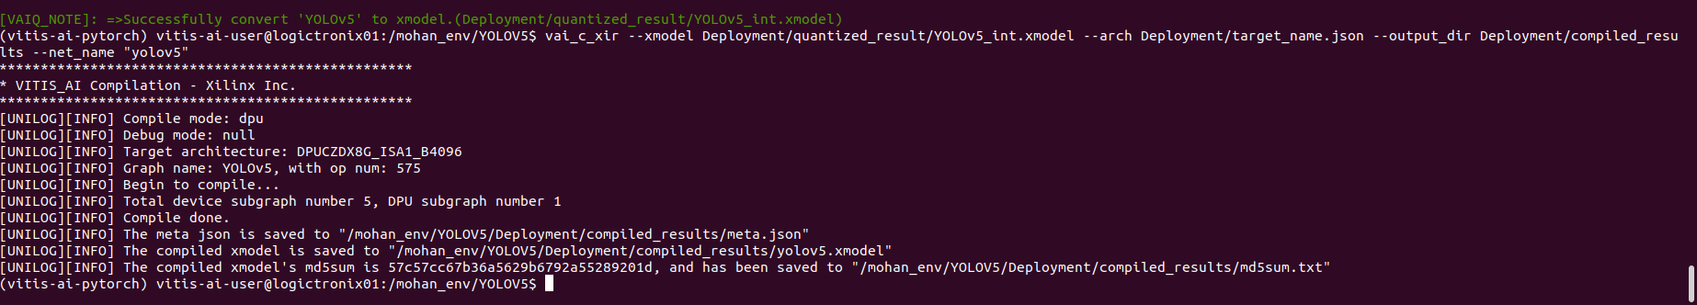
Inference on board:
After writing inference script to run model on DPU, and preprocessing and post processing on CPU which is independent of framework i.e. pytorch, successfully run on board and got output.

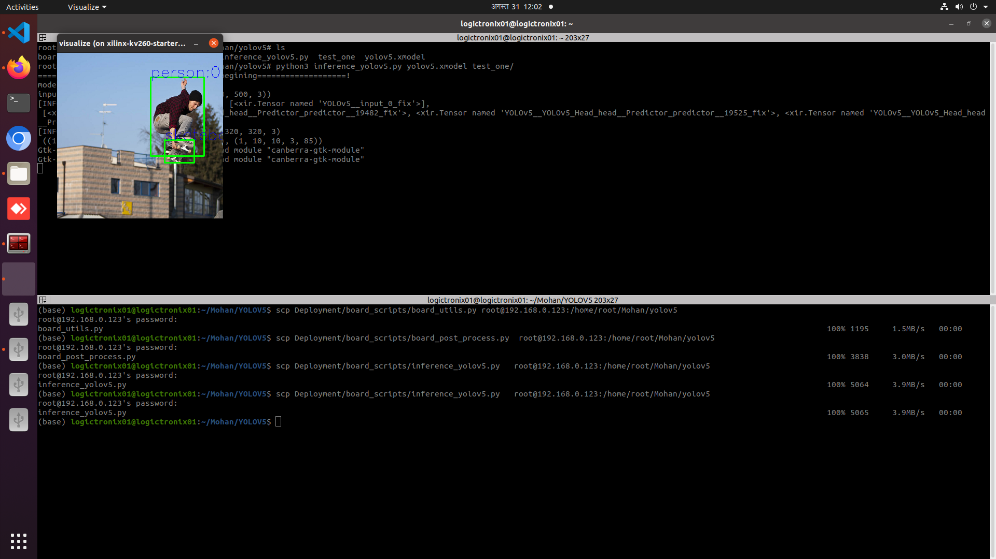
References:
[1] Yolov5 used to implement on board: [2] To understand about yolov5:
[3] Overview of yolov5 architecture:
[4] Yolov5 ultralytics:
[5] Vitis-AI tutorial for board inference:
[6] To write inference script for board:

